Measuring and Ordering Guide for Surround Mantels
The following diagram is a view of the fireplace BEFORE installing the surround. We will need to know the following measurements in planning your fireplace surround. Not all measurements may apply to your installation.

 | Measurements:  ____________ A - Facing Material Width  ____________ B - Facing Material Height  ____________ C - Facing Material Depth  ____________ D - Firebox Opening Width  ____________ E - Firebox Opening Height  ____________ F - Hearth Width  ____________ G - Hearth Height  ____________ H - Hearth Side Projection  ____________ I&J - Side Clearance | 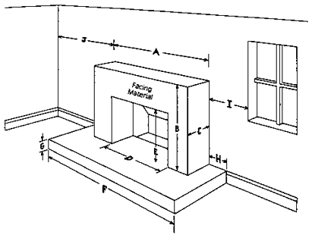

Additionally:
____________ Amount of facing material exposed each side of opening after installing surround
____________ Amount of facing material exposed above opening after installing surround
____________ Any other size or height restrictions
____________ Mantel Opening Height and Width

Instructions for Measuring Guide
1. A, B, and C dimensions are the non-combustible material ( marble, tile, brick, etc.) We want the opening dimensions of the mantel of overlap these measurements by at least ½”. However the outer dimensions of the mantel must be at least 4” larger than the A and B dimension to clear the inside structure. The offset for facing material needs to be generous for the C dimension. The scribe trim pieces are designed to fill the small space next to the tile up to ¾”.
2. D and E represent the firebox opening or the amount of black metal exposed to the inside edge of the facing. Under “Additionally” the amount of facing exposed to each side and above gives us the clearance to combustible code for the finished opening. D + 2 x (facing material exposed each side) = the finished opening width. E + facing material exposed above = the finished opening height.
3. Please note the F dimension as it relates to the Width of Legs at Hearth. If adjustment is necessary, you have the option of adjusting the leg width or reducing the opening width. The same is true for height requirements. You may adjust the apron height as well as the opening height being careful to maintain your clearance to combustible code.
4. I and J show the restrictions of the mantel shelf length. The mantel shelf should be no wider than A + 2 x (the smaller of the I or J dimensions).

